zoom meeting user guide
UW Medicine Advancement

Joining a zoom meeting
Step 1: The easiest way to join a Zoom meeting is by clicking the meeting link provided upon registration. It will begin with https://washington.zoom.us.
You can practice joining a Zoom meeting by clicking on this link to JOIN A TEST MEETING hosted by Zoom.
Step 2: It isn’t necessary to download and run the Zoom application to join a meeting. Just click join from your browser in the bottom, right of your screen.
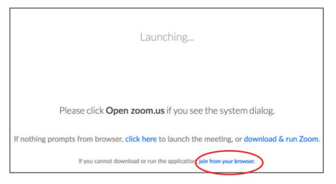

Step 3: Enter your name to join the meeting. Then click the Join button.
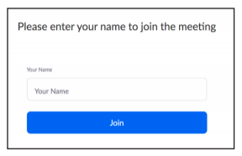

Step 3 Alternative: If you do not have access to the direct meeting link, you may connect by manually entering the Meeting ID at https://zoom.us/join.
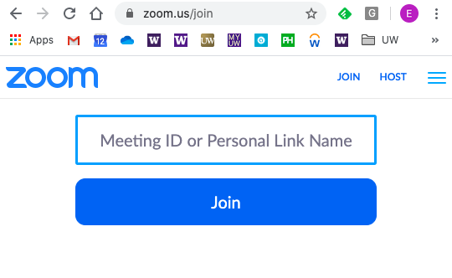
If the meeting requires a password, you will be prompted to enter the password after clicking the Join button.

Additional help from Zoom: For more information, and to watch videos on how to join a Zoom meeting, visit the Zoom Help Center page on Joining a Meeting.

Your zoom meeting controls
When you join a Zoom meeting, you will see a black bar at the bottom of your window with your meeting controls.

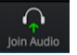
Click on this icon to select the source audio for the call. Click on Join Audio by Computer. You can also test your computer audio by clicking on Test Speaker and Microphone.

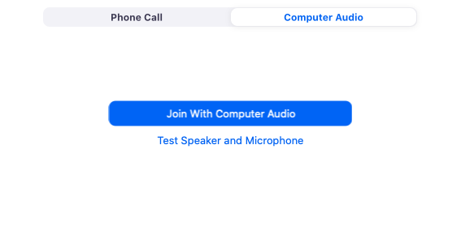

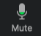
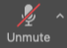
Once your audio is connected, you will see the Microphone icon. You can click on this icon to Mute and Unmute your microphone. At times, your meeting host may have disabled the option to mute.

Click on the Camera icon to start and stop your video. If you see the red slash through the camera, that means your video is off.

The Participants icon tells you how many people are currently in the meeting. Click on the icon to open your Participant Controls.

The new panel that opens after clicking the Participants icon lists the meetings participants and has the Participant Controls. These buttons can be used for non-verbal communication during the meeting.

The Chat icon accesses the chat window and will allow you to chat with other participants. You can send a message to the entire group or a private message to an individual participant. Visit the Zoom Help Center page on in meeting chats to learn more about Zoom chat.
(Please note: if you do not see a chat icon, your meeting host has turned off chat and it cannot be used during your meeting).
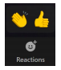
The Reactions icon is where you can quickly access more non-verbal communication options. From this icon, you can choose a Thumbs Up or Clapping emoji that will appear on your image when clicked.

Zoom Control Bar:
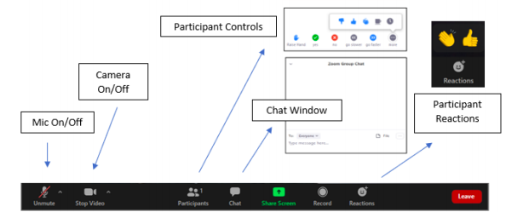

changing your meeting view
You can choose between two different meeting views in Zoom: Speaker View or Gallery View. Below are examples of both views and information on how to switch between them during your meeting.

Speaker View highlights the screen of the individual speaking during the meeting or presentation. The speaker will appear in a large time and al meeting participants appear in small tiles above the speaker. This is the default view when you join a Zoom meeting. Speaker view is ideal for ensuring all attention is on the one person speaking.
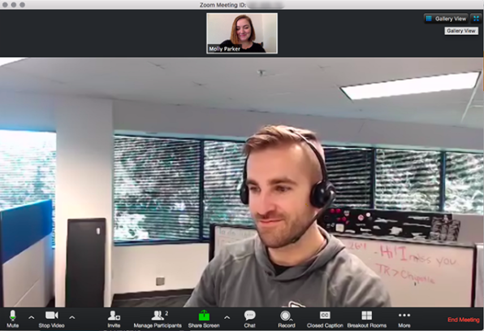

Gallery View allows you to see multiple meeting attendees at one time. All participant tiles are the same size and fill your window. Gallery View is ideal during conversations when you would like to view all participants. A yellow box will highlight the active speaker so you can quickly see who is speaking.
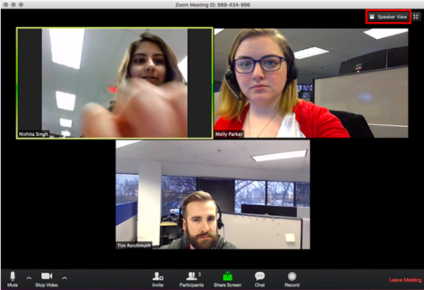

You can switch between Speaker View and Gallery View by clicking the View Option icons at the top right of your Zoom Window.
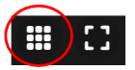
When you are in Speaker View, you can click on the Grid Icon or Gallery View icon in the top right of your window to switch to Gallery View.

When you are in Gallery View, you can click on the Speaker View icon in the top right of your window to switch to the Gallery View.

Presentation Mode is the view you will automatically get when a meeting host shares their screen to show a video or slideshow. Once presentation mode ends, your view will revert to Speaker View. You can change back to Gallery View by following the instructions above.

additional questions?
Check out the Zoom Help Center for more information and tutorials. Below are a few links to get you started:
- Zoom Help Center: Frequently Asked Questions
- Zoom Help Center: Getting Started
- Zoom Help Center: Joining a Meeting
- Zoom Help Center: Testing Your Audio
- Zoom Help Center: Virtual Background
- Zoom Help Center: In Meeting Chat
- Zoom Help Center: Video Layout
- Join a Zoom Test Meeting

